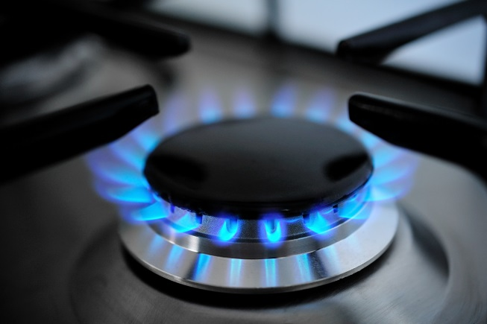Student worksheet

8.1 Mass is conserved in a chemical reaction

Pages 156–157 and 222

The law of conservation of mass

1 What are reactants? Where are they found in chemical equations?

2 What are reactants? Where are they found in chemical equations?

3 What does the law of conservation of mass state?

4 What do you think that this implies with regard to chemical equations?

5 What happens in a chemical reaction to the reactant atoms in order for them to form products?

6 For the following chemical reactions, write a worded equation, labelling the reactants and products.

a Methane reacts with oxygen to form carbon dioxide and water.

b Aluminium oxide is formed when aluminium reacts with oxygen.

c Magnesium burns in the presence of oxygen. This produces magnesium oxide.

d In cellular respiration, glucose reacts with oxygen and breaks down into carbon dioxide and water.

e Hydrogen peroxide breaks down into oxygen and water.

Extend your understanding

The results in the table below are from 5 different experiments:

|  |  |  |
| --- | --- | --- |
| Reaction | Total mass of the reactants (g) | Total mass after the reaction (g) |
| 1 | 45 | 38 |
| 2 | 22 | 22 |
| 3 | 13 | 14 |
| 4 | 29 | 29 |
| 5 | 78 | 78 |

7 Which reactions follow the law of conservation of mass? Explain why.

8 Which reactions do not follow the law of conservation of mass? Explain why.

9 For the reactions that do not follow the law of conservation of mass, there have been experimental errors. Explain what these errors may have been to cause these results.

10 How could these experiments be improved so that these errors are not repeated in the future?

Student worksheet

8.2 The rearrangement of atoms in a chemical reaction can be shown using a balanced equation

Pages 158–159 and 223

Balancing chemical equations

1 How can you describe chemical reactions?

2 What must a balanced chemical equation have?

3 It is often useful for visual learners to use coloured balls to represent atoms in molecules. Under the chemical equations below, draw the molecules in straight lines using balls and then balance the equation. To balance the equation add more molecules beneath the ones you have already drawn until you have an equal number of coloured balls on both sides of the grey line. Each atom must be a different coloured ball. The first one has been provided for you as an example.

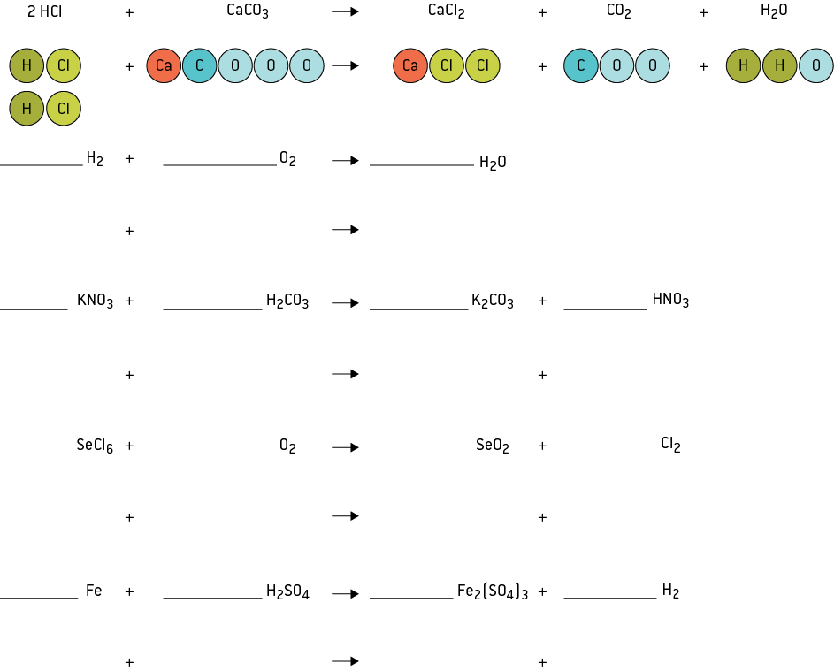

Extend your understanding

4 Balance the following chemical equations (space has been provided if you would like to draw the atoms):

a _______ Na + _______ Cl2 🡪 _______ NaCl

b _______ Al2O3 🡪 _______ Al + _______ O2

c _______ Mg + _______ O2 🡪 _______ MgO

d _______ H2SO4 + _______ Na 🡪 _______ Na2SO4 + _______ H2

e _______ HNO3 + _______ MgO 🡪 _______ Mg(NO3)2 + _______ H2O

f _______ HNO3 + _______ Na2CO3 🡪 _______ NaNO3 + _______ H2O + _______ CO2

g _______ C6H12O6 + ______ O2 🡪 ______ CO2 + _______ H2O

h _______ C3H8 + _______ O2 → _______ CO2 + _______ H2O

i _______ Cl2 + _______ H2S → _______ S + _______ HCl

j _______ C2H6 + _______ O2 🡪 _______ CO2 + _______ H2O

Student worksheet

8.3 Endothermic reactions absorb heat from the surroundings. Exothermic reactions release energy

Pages 160–161 and 224

Exothermic and endothermic reactions

1 What is an exothermic reaction?

2 What does exothermic mean?

3 Explain the amount of energy in reactants and products in an exothermic reaction. Draw a graph to help you.

|  |
| --- |
|  |

4 What is an endothermic reaction?

5 What does endothermic mean?

6 Explain the amount of energy in reactants and products in an endothermic reaction. Draw a graph to help you.

|  |
| --- |
|  |

7 Give an example of an exothermic reaction and how it is used in the real world.

8 Give an example of an endothermic reaction and how it is used in the real world.

Extend your understanding

Hydrogen (H2) and oxygen (O2) have 0kJ of energy. In order to break their bonds and form water, 1370kJ of energy is required. Once these bonds have been broken, the atoms rearrange to form water which contains -572kJ of energy.

9 On the graph below, draw the process of hydrogen (H2) and oxygen (O2) breaking their bonds to form water.

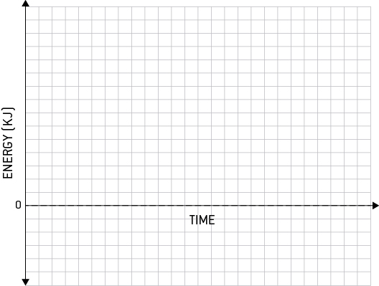

10 Catalysts are used to help a chemical reaction to occur faster. After introducing a catalyst, the energy required to break the bonds of hydrogen (H2) and oxygen (O2) lowers from 1370kJ to 500kJ. On the graph you drew above, draw a second process of hydrogen (H2) and oxygen (O2) forming water with a catalyst.

Student worksheet

8.4 Acids have low pH. Bases have a high pH.

Pages 162–163 and 224–225

Acid and base chemical reactions

1 Summarise the differences between acids and bases in the following table.

|  |  |  |  |  |
| --- | --- | --- | --- | --- |
|  | Acids | | Bases | |
|  | Weak | Strong | Weak | Strong |
| What does it taste like? |  | |  | |
| What does it feel like? |  | |  | |
| What does it contain in its chemical structure? |  | |  |  |
| What does it read on the pH scale? |  | |  | |
| Colour in universal indicator? |  |  |  |  |
| What litmus paper should be used and what colour does it turn? |  | |  | |
| 3 chemical examples |  |  |  |  |
| Examples that are found around the home |  |  |  |  |

2 Label the following diagram of the pH scale.

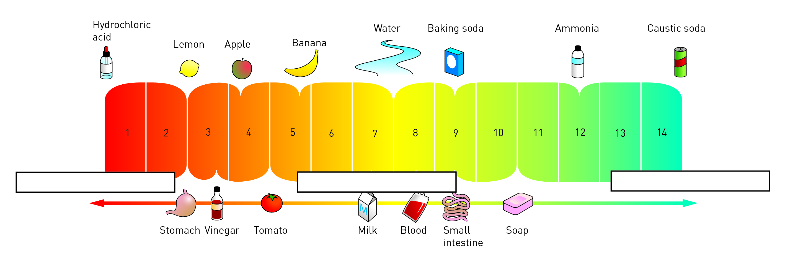

3 What do the colours on the above pH scale represent?

Extend your understanding

4 Your teacher puts 3 test tubes on your science bench and asks you to identify which is the salt solution, the acid solution and the alkali solution. Outline what you would use to determine the answer and what results you would obtain.

5 The following are results of some substances that have been tested in the science laboratory with a variety of indicators; red litmus, blue litmus and Universal indicator. Look at the results and complete the table below.

|  |  |  |  |  |  |
| --- | --- | --- | --- | --- | --- |
| Substance | What colour will red litmus paper turn? | What colour will blue litmus paper turn? | pH read on universal Indicator | Acid, base or neutral? | Example of a substance that it could be. |
| A |  |  | pH 7 |  |  |
| B |  |  | pH 4 |  |  |
| C |  |  | pH 2 |  |  |
| D |  |  | pH 11 |  |  |
| E |  |  | pH 8 |  |  |

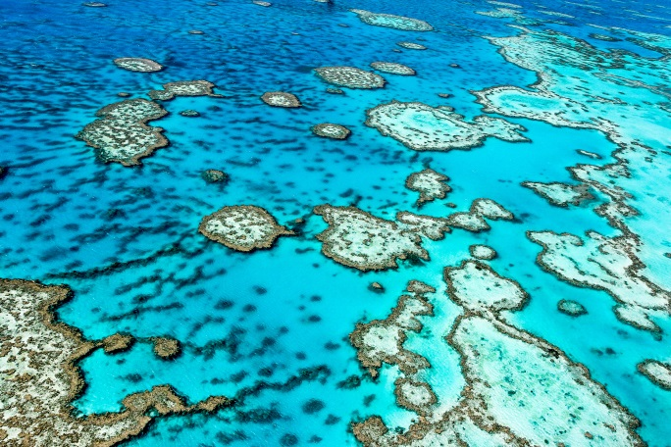Student worksheet

8.5 Acids can neutralise bases

Pages 164–165 and 226

Neutralisation reactions

1 What are the products of acid base reactions?

2 Why is this called a neutralisation reaction?

3 What does a chemical salt contain?

4 If citric acid produces salts called citrates, and sulfuric acid produces salts called sulfates, what salts will the following acids produce?

a hydrochloric acid (HCl)

b nitric acid (HNO3)

c carbonic acid (H2CO3)

d phosphoric acid (H3PO4)

5 What are the products of acid and metal carbonate reactions?

6 Identify the following reactions as acid base neutralisation or acid metal carbonate neutralisation

a HCl + NaOH 🡪 NaCl + H2O

b HCl + NaHCO3 🡪 NaCl + CO2 + H2O

c HNO3 + Na2CO3 🡪 NaNO3 + CO2 + H2O

d KOH + H2SO4 🡪 K2SO4 + H2O

e H3PO4 + Ba(OH)2 🡪 Ba3PO4 + H2O

f H2SO4 + MgCO3 🡪 MgSO4 + CO2 + H2O

7 Explain how rising CO2 levels have decreased the pH of the world’s oceans.

8 If the pH of oceans is lowering are they becoming more acidic or basic?

9 What effect does this have on plants and animals living in the world’s oceans. Provide an example.

Extend your understanding

10 For the absorption of CO2 in the world’s oceans write worded equations and balanced chemical equations for the 2 processes.

a What is Process 1?

• worded equation:

• chemical equation

b What is Process 2?

• worded equation

• chemical equation

11 What is the name given to the process of the breakdown of the coral?

12 Explain why it is given this name.

13 What is the problem that you can see in the second process above?

14 Conduct research about the accurate chemical equation for the breakdown of coral and write it below:

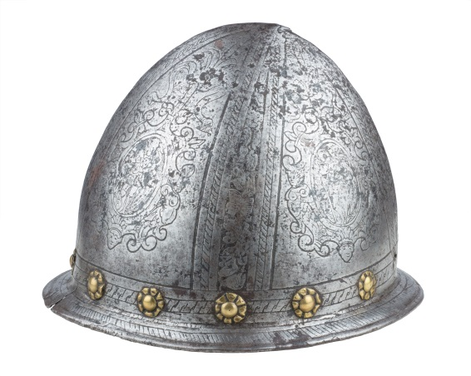Student worksheet

8.6 Acids react with metals to produce hydrogen and salt

166–167 and 227

Acid and metal reactions

1 What are the products for acid + metal reactions?

2 Provide an example of an acid + metal reactions as a:

a worded equation:

b chemical equation:

3 Explain how reactions between metals and acids can form artwork.

4 How does acid rain form?

5 What are the different types of acid rain?

6 Which is the worst type of acid rain?

7 What effect does acid rain have on marble, limestone or various metals?

8 What is the relationship of acid strength and rate of corrosion?

9 How can you protect structures against acid rain?

10 The following graph displays the trend between the pH of acids and the amount of corrosion.

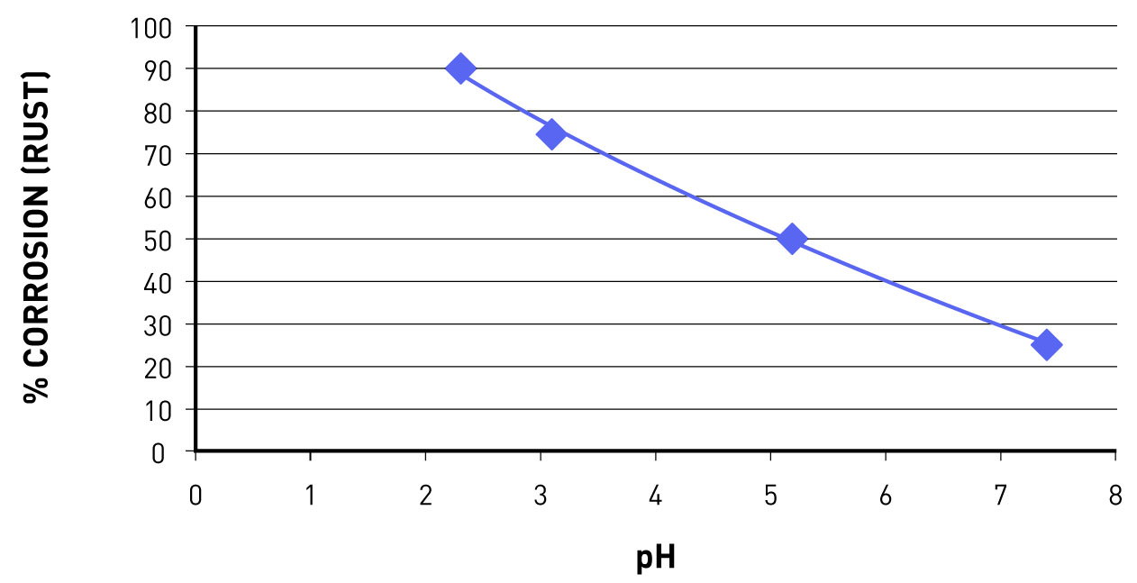

a Will a strong acid have a high or a low pH?

b The following acids are listed in order of strength (strongest to weakest): H2SO4, HNO3 and H2CO3. Which causes the most damage?

Extend your understanding

11 In which parts of the world does acid rain caused by sulfuric acid form?

12 Explain how this process of the production of sulfuric acid occurs naturally.

13 Explain how humans contribute to acid rain caused by sulfuric acid.

14 How can humans reduce the amount of acid rain from sulfuric acid?

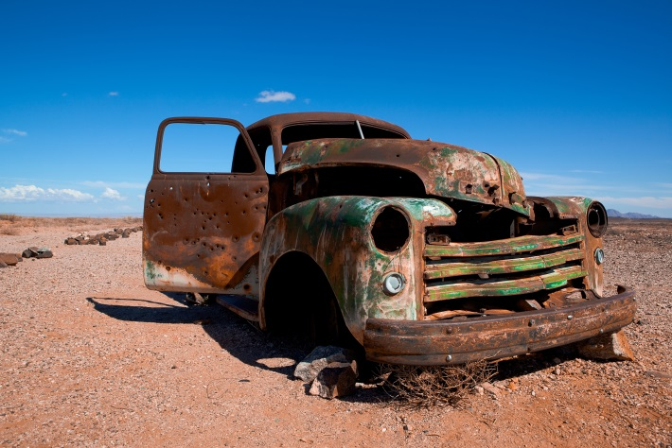Student worksheet

8.7 Oxidation reactions use oxygen to form new products

Pages 168–169 and 228

Oxidation reactions

1 What is an oxidation reaction?

2 What has a chemical become when it has undergone this type of reaction?

3 What is formed when a metal is oxidised?

4 Provide a worded equation of a metal reacting with oxygen.

5 Provide a chemical equation of a metal reacting with oxygen.

6 What is formed when a non-metal is oxidised?

7 Provide a worded equation of a non-metal reacting with oxygen.

8 Provide a chemical equation of a non-metal reacting with oxygen.

9 What is formed when you react a non-metal oxide with water?

10 Which group of elements do not react with oxygen?

11 Suggest a reason why this group of elements will not react with other elements**.**

12 Are the following compounds metal oxides or non-metal oxides?

a H2O

b MgO

c CaO

d Na2O

e CO2

f NO2

g Li2O

Extend your understanding

13 For the following oxidation reactions write the worded equation and the balanced chemical equation

a carbon and oxygen react to form carbon dioxide

• worded equation

• chemical equation

b lithium and oxygen react to form lithium oxide (formula in question 12)

• worded equation

• chemical equation

c nitrogen and oxygen react to form nirtogen dioxide

• worded equation

• chemical equation

d iron and oxygen react to form rust (iron oxide - FeO)

• worded equation

• chemical equation

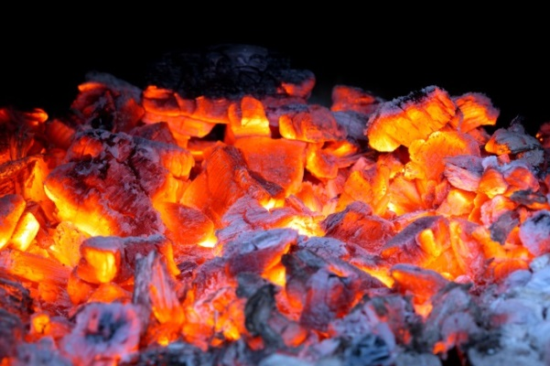Student worksheet

8.8 Combustion reactions need fuel and oxygen to produce carbon dioxide and water

Pages 170–171 and 228

Combustion reactions

1 What is combustion?

2 Why do you think that people often refer to combustion as oxidation?

3 What type of chemical is reacted with oxygen in a combustion reaction?

4 What do we call this type of chemical in Science?

5 Provide a general equation of a combustion reaction.

6 What is meant by the term 'excess oxygen'?

7 What is meant by the term 'limited oxygen'?

8 Compare the products of combustion with excess oxygen and combustion with limited oxygen.

9 For the combustion of methane:

a write the worded equation.

b write the balanced chemical equation.

c explain why the water produced as a gas.

Extend your understanding

10 Write worded combustion equations and balanced chemical equations for the following hydrocarbons.

a ethane (C2H6) in limited oxygen

• worded

• chemical

b propane (C3H8) in excess oxygen

• worded

• chemical

c butane (C4H10) in limited oxygen

• worded

• chemical

d hexane (C6H14) in excess oxygen

• worded

• chemical

e heptane (C7H16) in excess oxygen

• worded

• chemical

f octane (C8H18) in excess oxygen

• worded

• chemical

g nonane (C9H20) in limited oxygen

• worded

• chemical

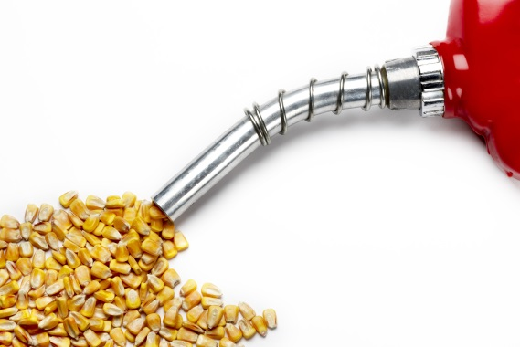Student worksheet

8.9 Fuels are essential to Australian society

Pages 172–173

Uses of fuels

1 What is the purpose of a fuel?

2 What considerations are there in choosing a fuel for a use?

3 How can the combustion of fuels to produce energy be contained?

4 What fuels are used to produce energy?

5 How is alcohol used in fuels and how much is allowed?

6 What are the names of the alcohols that are used?

7 In what circumstances are these two alcohols used?

8 Why are alcohols able to be used? Provide a chemical equation to support your answer.

9 How are alcohols produced and why is this classified as renewable?

10 Why is there concern regarding the production of biofuels? What is required?

11 According to Oxfam, what are the 2 main disadvantages of biofuels? Summarise these issues.

12 Why are alcohols preferred over hydrocarbons in the production of fuels?

Extend your understanding

13 Complete the following table by drawing the hydrocarbons and alcohols with the correct number of carbons.

|  |  |  |  |
| --- | --- | --- | --- |
| Number of Carbons | Prefix | Hydrocarbon | Alcohol |
| 1 | meth |  |  |
| 2 | eth |  |  |
| 3 | prop |  |  |
| 4 | but |  |  |
| 5 | pent |  |  |
| 6 | hex |  |  |
| 7 | hept |  |  |
| 8 | oct |  |  |
| 9 | non |  |  |
| 10 | dec |  |  |